## Rajesh Ayyappanpillai

## Module 8.2-Assignment

## **Assignment: Movies: Update & Deletes** 5/03/2024

**Movies: Update & Deletes:**

**Insert:**

**

**Update:**

**List After Update:**

**Delete:**

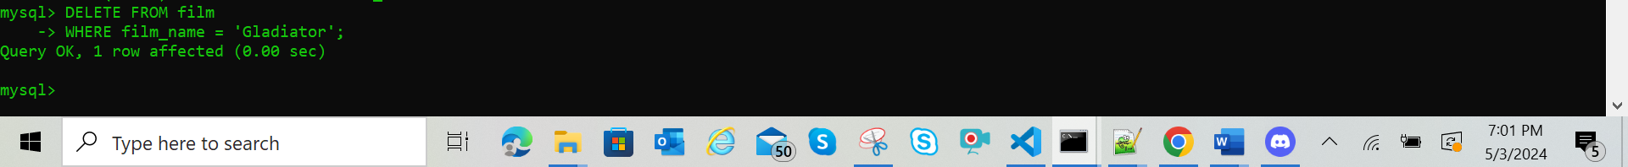

**List After Delete ( display label is changed)**

**Error: “1054 (42S22): Unknown column 'film_genre_id' in 'field list'”**

**Resolved & Final List:**

